**Jenkins Build Process**  
  
  
1. Logged in into Jenkins Server with you credentials

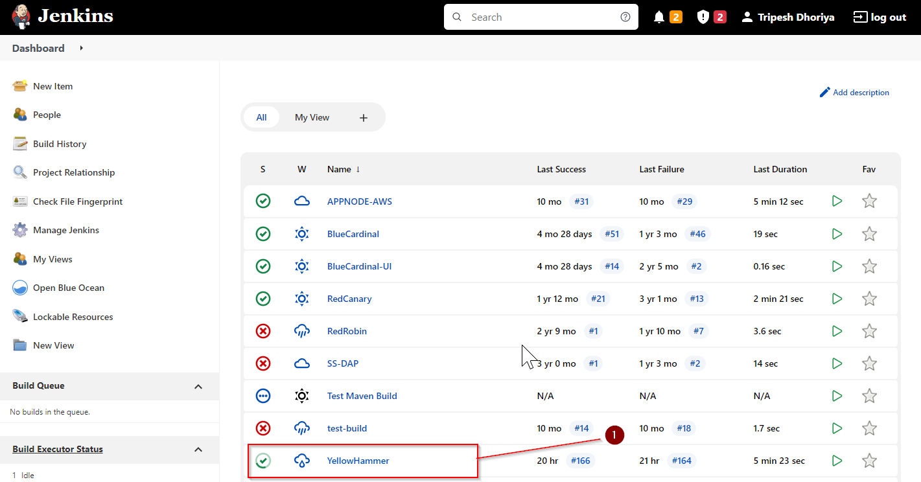

2 . Click on **Yellowhammer Pipeline** for creating build.  
  
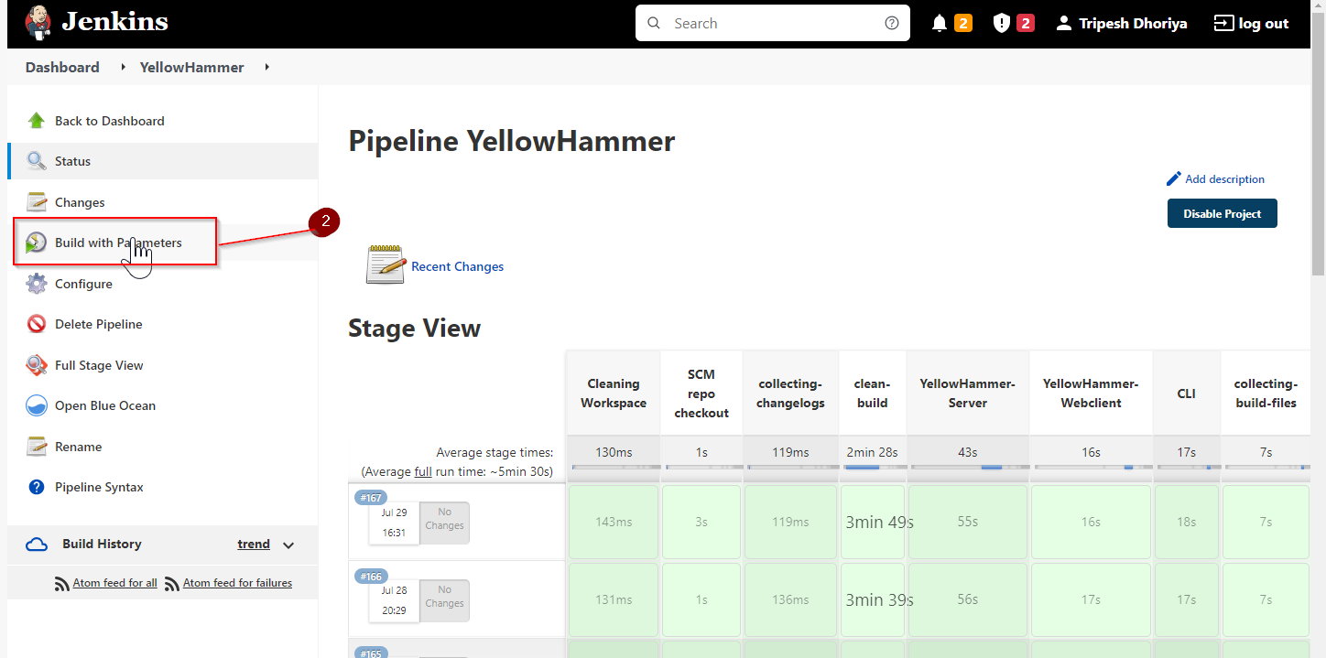

1. Click on **Build with parameters** and select correct branch from RIVISION which you want to create build.  
     
   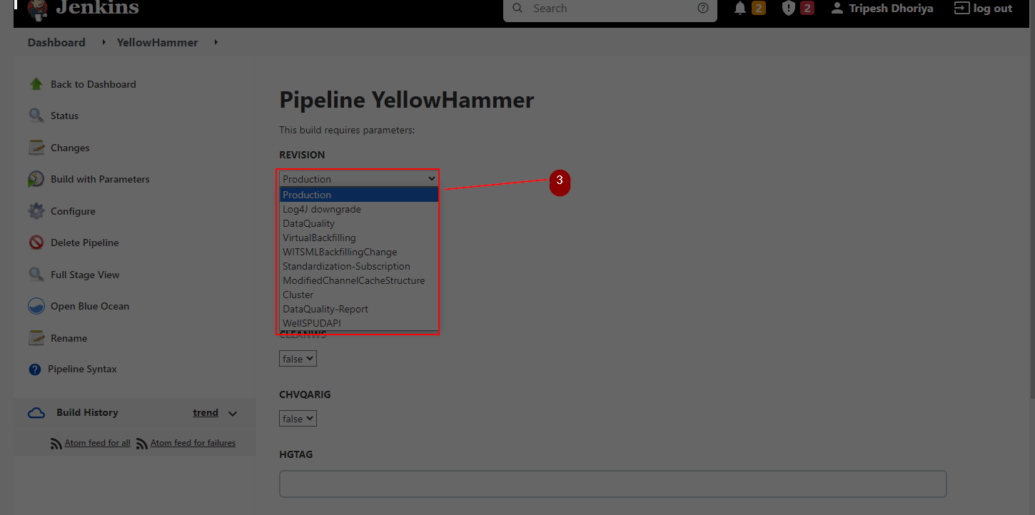  
     
     
   5. Click on **Build**  button without any changes on other sections.  
     
   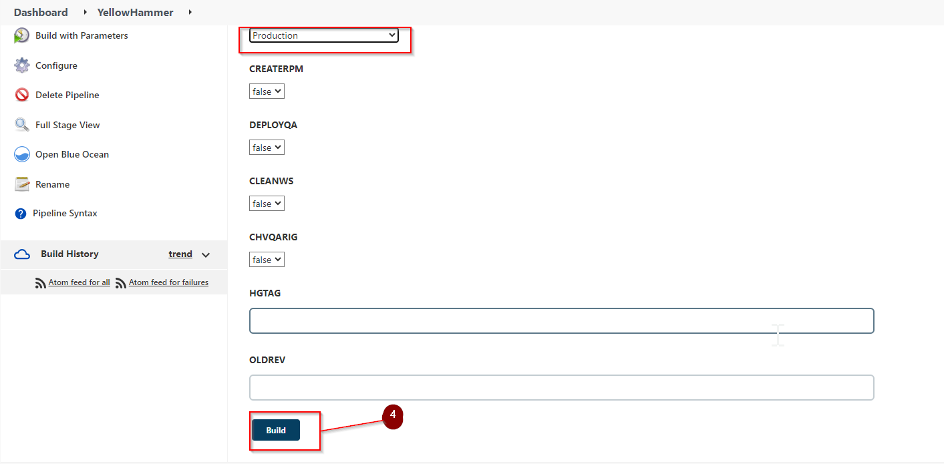
2. Check your build progress here. Click on build number for log tracing  
   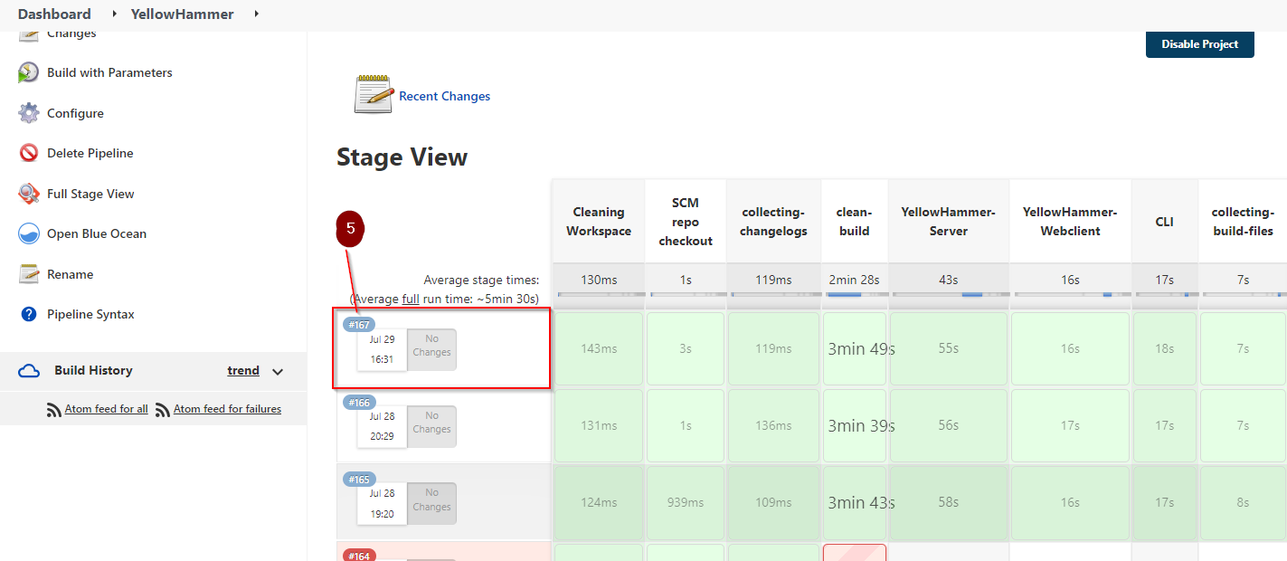
3. For log tracing.

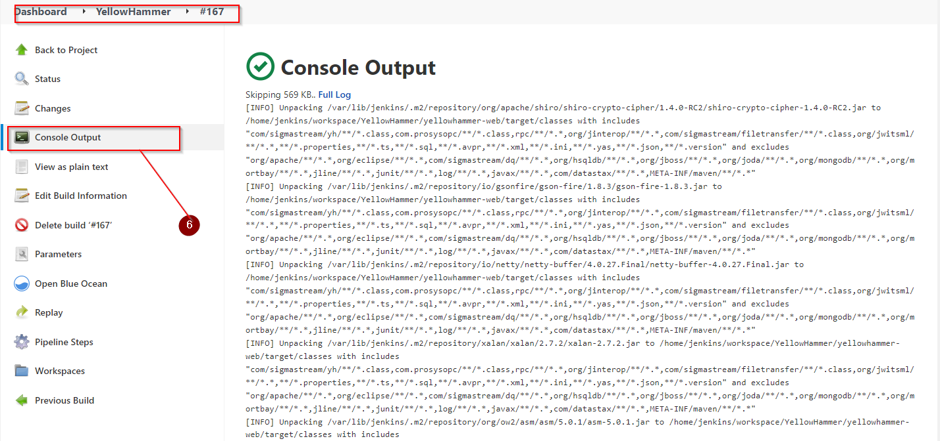

1. After complet build you will get SUCCESS message at the end of log file. If any error you will get then raise concern with DEV team.  
     
   
2. For Build collection you need to take access of 1.108 server which jenkins server.  
   Check on   
   **PATH: /home/Jenkins-Build-Files/YellowHammer/2023**On that path you will get directory date and time wise. 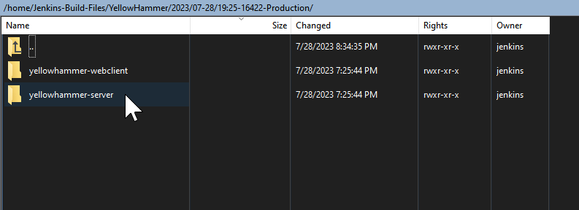  
     
   Here you will get two directory:  
    1. Yellowhammer-webclient
3. Yellowhammer-server

On Yellowhammer-server   
Take 2 file which is : **ROOT.war** and **yguard_mappings.log.xml**

On Yellowhammer-webclient  
Take file and directory as like :  **i18n, webapp.zip and yh-webclient.jar**For deployment please referred deployment guide line